Manual Test Plan Week 3:

1. Run testing.py
2. Verify that the plot is updating real time values where the y values are in between 1-100

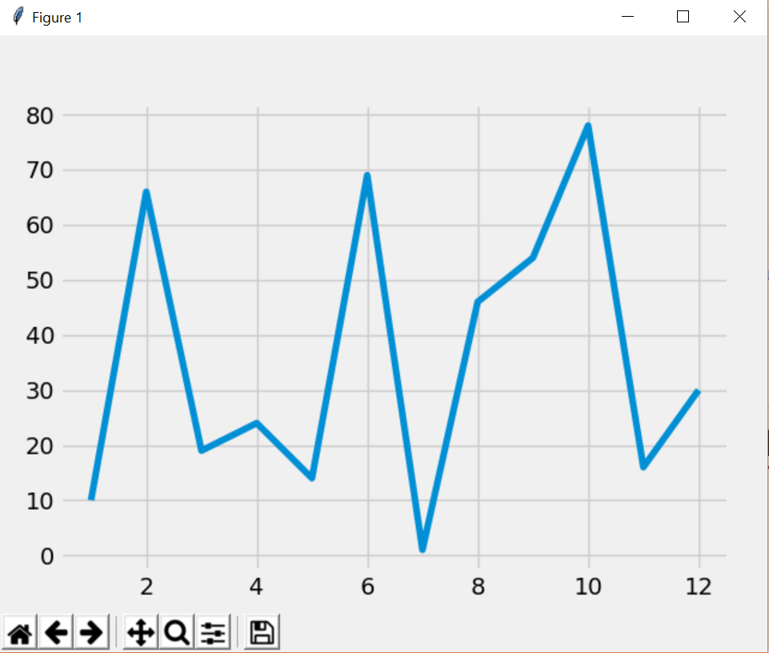

Testing Database:

- While running main_week3 verify that the database is being updated on firebase

